【无机化学论坛】 The Beauty of Molecules
报告: Prof. Shie-Ming Peng
Department of Chemistry, National Taiwan University,
Institute of Chemistry, Academia Sinica.

时间：2019年5月9日（周二） 下午14:00—15:30
地点：北京大学化学学院A区717报告厅.
Abstract:
The lecture is prompted by the paper of Prof.Roald Hoffmann (The Journal of Aesthetics and Art Criticism, 48, 191-204, 1990) and bead work of my colleague, Prof. Bih-Yaw Jin. The intention of the lecture is to introduce the structural chemistry to general audiences. Many beautiful molecules are presented by drawing, picture or real 3D model instead of difficult chemist’s language. After simple introduction of chemical bond, many molecules are showing from organic molecules to inorganic molecules, coordination complexes and organometallic complexes. Then giant molecules, proteins, DNA seven virus will be illustrated. The final remark will be focused on my research molecules: metal string complexes. These molecules are fundamentally important in the study of metal-metal bonding and also have great potential applications as molecular electronics.

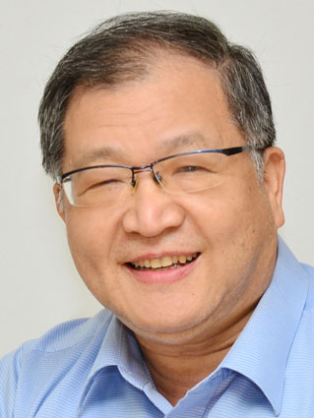
Curriculum Vitae
Name: PENG, SHIE-MING
Date of Birth: March 2, 1949
E-mail: smpeng@ntu.edu.tw
Tel: 886-2-2363 8305
Fax: 886-2-8369 3765
Address: Department of Chemistry National Taiwan University
No.1, Sec. 4, Roosevelt Rd., Taipei, Taiwan, R.O.C. 10617
Educational and Professional
National Taiwan University B.S. 1970
The University of Chicago Ph.D. 1975
Northwestern University Post doctor 1975-1976
Current Position and Relevant Experience
National Taiwan University Professor 1980-Now
Universitaet Muenster, Germany Visiting Professor 2012
Academia Sinica Vice President 2011-2014
Universite de Strasbourg (ULP) , France Visiting Professor 2009
Institute of Molecular Science, Japan Visiting Professor 2008
Chuo University, Japan Visiting Professor 2004
University of Zaragoza, Spain Visiting Professor 2003
Chemical Society Located in Taipei President 2001-2002
Universite Louis Pasteur, France Visiting Professor 2000
National Taiwan University Vice President 1999-2002
Institute of Molecular Science, Japan National Laboratory Visiting Scholar 1991
Department of Chemistry, National Taiwan University Chairman 1987-1990
Institute of Chemistry, Academia Sinica Acting Director 1985-1987
Max-Planck Institute of Solid State Research Humboldt Fellow 1983-1984
National Taiwan University Associate Professor 1976-1980
Honors and Awards
Humboldt Fellow 1983
Outstanding Young Alumni, National Taiwan University 1985
Sun-Yat Sen Foundation, Academic Award 1991
Chinese Chemical Society (Taipei), Academic Award 1992
Ho Foundation, Academic Award 1996
National Science Council, Outstanding Research Award 1986; 1988; 1990; 1993
National Science Council, Distinguished Researcher 1995; 1998
Ministry of Education, Science Award 1996
Ministry of Education, Chair Professor 1997-2000
Member of Academia Sinica (Academician) 1998
Chang Foundation, Academic Award 2000
TWAS (The Third World Academy of Sciences) Prize in Chemistry 2002
Member of TWAS 2004
Phi Tau Phi Taiwan Chapter, Outstanding Achievement Award 2005
Y.Z. Hsu Scientific Chair Professor 2006
Taiwan-Frence Science Prize 2008
Chair Professor, National Taiwan University 2006; 2009; 2014
Fellow of the Royal Society of Chemistry 2009
International Award, Japan Society of Coordination Chemistry 2011
FACS, Foundation Lectureship Award 2011
Presidential Science Prize of Taiwan 2013
Luigi Tartufari International Chemistry Prize, Italin Academy of Sciences 2014
Russian Academy of Engineering, Foreign Member 2014
Japan Society for the Promotion of Science (JSPS), Fellow 2015
Distinguished Chinese Visiting Scholar Lectureship of Hong Kong Baptist University 2015

